Key Issue 1: Where Are Ethnicities Distributed?
Pages 226-231

***Always keep your key term packet out whenever you take notes from Rubenstein. As the terms come up in the text, think through the significance of the term.
- Define ethnicity:

- Define race:

- What is racism?

- What are the three most numerous ethnicities in the United States?

- What is the “problem” with the way the U.S. Census Bureau defines “Asian”?

- What is the difference between “African-American” and “black”?

- How does the U.S. Census Bureau consider Hispanic/Latino?

- Provide an example to illustrate that African-Americans or Hispanics in the U.S. are more urbanized.

- In the chart below, explain where each ethnic group is clustered in the United States.

Hispanics
African American
Asian American

Key Issue 2: Why Do Ethnicities Have Distinctive Distributions?
Pages 232-237

- Complete the chart below to summarize the historic migration patterns of African Americans.
Forced Migration | Interregional Migration | Intraregional Migration

- Describe the following concepts dealing with the geography of race:
  - “White Flight”

  - “Blockbusting”

  - “Separate but Equal”

- Define apartheid:

- Explain the key components of the apartheid system:

- Complete the following timeline of South African history and annotate the map of 10 homelands.
1652 –

1795 –

1948 –

1991 –

1994 -

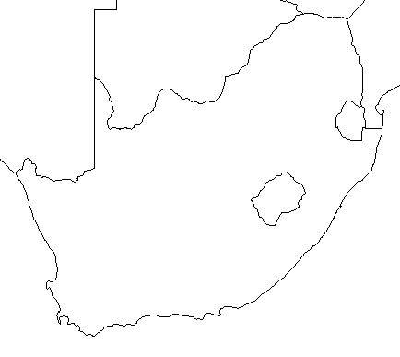

Key Issue 3: Why Do Conflicts Arise Among Ethnicities?
Pages 238-245
- Define nationality:

- Though they are very similar, use the chart below to show how nationality differs from ethnicity.

Ethnicity | Nationality

- Explain the difference between ethnicity and nationality in the United Kingdom.

- What is nationalism?

- How do nations and states foster it?

- What are centripetal forces?

- Read “Ethnic Competition in Lebanon” and complete the case study by listing the religions of Lebanon and annotating them on the map provided (use map pg. 240).

Religions of Lebanon | 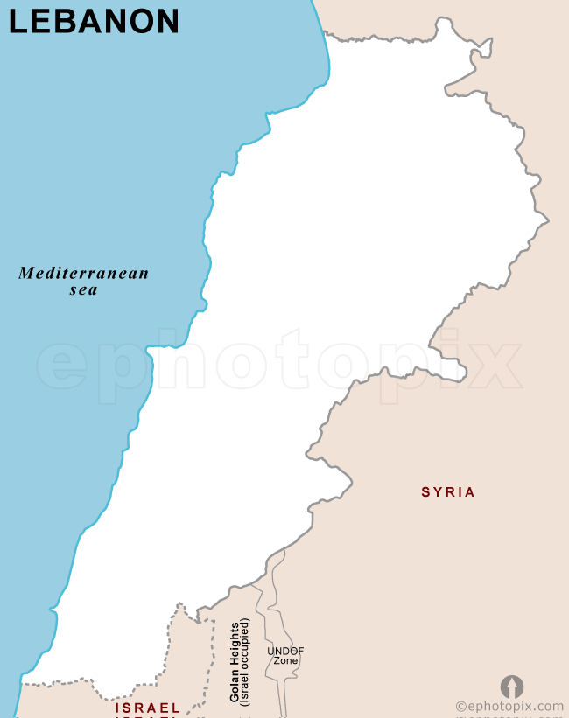

- How did Lebanon’s 1943 constitution seek to solve the religion problem?

The president…

The premier…

The speaker of the chamber of deputies…

The foreign minister…
- How has the make-up of the population changed since 1943?

- What happened in 1975? How has it been resolved?

- Complete the chart that compares the two ethnicities of Sri Lanka in terms of language and religion.

Ethnic Group and % | Language (family, etc.) | Religion | Where?

- How has violence between these two groups (which goes back 2,000 years) been suppressed during the past 300 years?

- What occurred in 1948?

- Which group is unhappy? Why?

- Annotate the map of the religious-ethnic geography of the island of Ceylon, the country of Sri Lanka.

- When the British ended colonial control of South Asia in 1947, how was the region divided politically, and how was the region divided ethnically (religiously)?

- How many people found themselves on the “wrong side of the boundary” in the 1940s?

- How many Muslims migrated from India to West Pakistan (Pakistan, today)?

- How many Muslims migrated to East Pakistan (Bangladesh, today)?

- How many Hindus migrated from East and West Pakistan into India?

- What happened to many of the refugees as they traveled?

- Why is the region of Kashmir a problem?

- Note the following regions on the map below:

India  Pakistan  Bangladesh  Jammu & Kashmir  Sri Lanka  Nepal  Butan  Myanmar  China  Afghanistan | 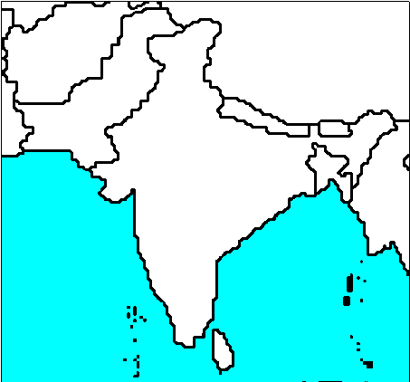

- Discuss some of the issues that the Kurds suffer from.

- In the chart below, bullet key points about ethnic diversity in Western Asia.
Iraq | Iran | Afghanistan | Pakistan

Key Issue 4: Why Do Ethnicities Engage in Ethnic Cleansing and Genocide?
Pages 246-255

- Define ethnic cleansing:

- How is ethnic cleansing different than normal warfare?

- List the countries of the Balkan Peninsula.

- List important/interesting facts regarding the creation of the post-WWI country of Yugoslavia.

- Regarding the Yugoslav refrain that was common during the rule of Josip Tito, identify the following of Yugoslavia’s:

FIVE NATIONALITIES…

FOUR LANGUAGES…

THREE RELIGIONS…

TWO ALPHABETS…

- What ethno-political problems did the country face after the death of Tito in the 80s and the fall of Communism in the 90s?

- Why did Serbs and Croats in Bosnia (aka Bosnia-Herzegovina) ethnically cleanse themselves of Bosnia Muslims?

- What was agreed upon at the accords signed between these rival ethnicities in Dayton, Ohio in 1996?

- Who got the best deal? Who got the worst deal? Explain.

- What country controlled Kosovo?

- What ethnic group lives in Kosovo (and %)?
- With the breakup of Yugoslavia, what began to happen in Kosovo?

- How did the U.S. and U.N. respond?

- Define balkanized:

- Define balkanization:

- If peace comes to the Balkan Peninsula in the next few years, why will it be “in a tragic way” according to the author of the textbook?

- Make notes on major issues in each of these ethnic conflicts as well as shade and annotate the map as necessary.

Case Study: Africa
Ethiopia & Eritrea | 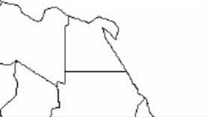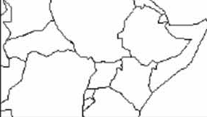
Sudan |  | Somalia

- Give the historical background of the two rival groups in Central Africa’s countries of Rwanda and Burundi.

Hutus | Tutsis

- What is the situation in Rwanda and Burundi today?

